**Department of Student Affairs  
Office of Military and Veteran Affairs**

**Colleague: MILS Screen**

Effective: August 22, 2014

Updated: v2, J. Busbey, 8.28.14

**BACKGROUND**

In April 2014, new functionality was introduced in Colleague for managing the student records of military and veteran students. MILS (Military Student Information) identifies a student’s Primary Military Status, Military Installation, tuition benefit they are using, whether they have had a Student Agreement completed or not and when, MOS Rating, and Pay Grade. Some of this functionality replaced what was previously in the MINF screen and the NAE screen, while other functionality is brand new to Colleague.

**THE PURPOSE OF THIS PROCEDURE IS**

* Inform users what information can be identified in MILS
* Inform users how and when information should be entered and updated in MILS
* Inform users of importance of maintaining End Dates in MILS

**DEFINITIONS**

* Current Servicemember: a student in any military branch who is Active Duty, National Guard, or Reserves
* Federal Tuition Assistance (FTA): funding available for current servicemembers in all military branches
* GoArmyEd (GAE): student using FTA through the GoArmyEd portal
* National Guard Scholarship (NGS): student who has been awarded funding through the Ohio National Guard Scholarship Program (ONGSP)
* SF182 Army Civilian Training: Army Civilian using funding through GoArmyEd portal

**RELATED RESOURCES**

* GoArmyEd portal: <https://www.goarmyed.com/>
* Ohio National Guard Scholarship Program: <http://ong.ohio.gov/scholarship_index.html>
* AI (Air Force) portal: <https://aiportal.acc.af.mil/aiportal/>
* Coast Guard Tuition Assistance: <http://www.uscg.mil/yotf/cgi/active_duty/pay_for_college/ta/default.asp>
* Navy Tuition Assistance: <https://www.navycollege.navy.mil/ta_info.aspx>
* Marine Corps Tuition Assistance: <https://www.navycollege.navy.mil/docs/TAAppPaperVers_110207.doc>

**MILS OVERVIEW**

1. The MILS screen is where we can identify if students with Military Status of Active Duty, National Guard, or Reserves (or an Army Civilian) are using Tuition Assistance benefit(s) available through their branch of service
2. Primary Military Status shown at top of screen – same information from PEMS
3. Student should **NEVER** have a primary Military Status = Veteran and have **active** funding in the MILS screen

* Can only be utilizing one of these benefits if they are Active Duty, National Guard, or Reserves

1. If any information does not match, as shown in example below, need to update PEMS

* Can get directly to PEMS by clicking Detail button (see arrow)

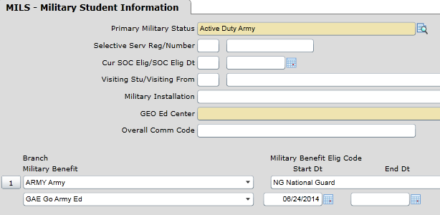

* Should also update PEMS if you notice this field is blank

**GOARMYED**

1. If student is using GoArmyEd funding, should be tracked in MILS

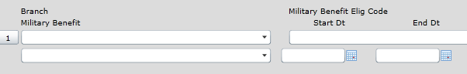

1. Must select Military Branch, Military Status, Military Benefit, Start Date

* Hint: Military Branch will always be Army, Status either Active, National Guard, or Reserves

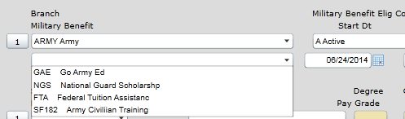

1. When to enter End Date

* Student’s overall GoArmyEd funding is completely exhausted
* Student separates from Army
* Student’s primary status in PEMS should also be changed to Veteran
* Date of separation can be obtained from GoArmyEd – student’s Personnel tab

1. When NOT to enter End Date

* Student taking course(s) outside of portal for a term or two
* Student account “on hold”
* Student using other funding instead – e.g. National Guard Scholarship, VA Benefits
* Student out of funding for the fiscal year

**NATIONAL GUARD SCHOLARSHIP**

1. If student is using the National Guard Scholarship, should track eligibility in MILS
2. Similar to entering GoArmyEd funding

* Need Branch (always Army or Air Force) and Status (always National Guard)

1. Entering National Guard Scholarship information

* When student provides approval letter, add National Guard Scholarship in MILS
* Start Date: enter based on when you receive approval letter

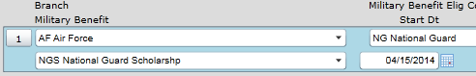

* End Date: use **end of term**, since scholarship eligibility is determined on term by term basis
* Summer terms: August 1
* Fall terms: January 1
* Winter terms: May 1
* Enter Communication Codes
* Summer: VAC14NG1
* Fall: VAC14NG2
* Winter: VACNG3

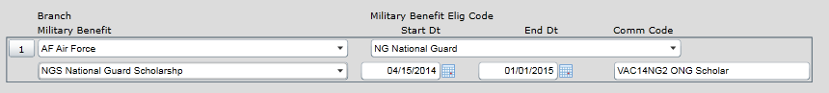

1. Managing National Guard Scholarship Information

* End Dates should be updated term-by-term as students submit their approval letters

1. Documenting National Guard Scholarship receipt

* Note in STCM and create CRM interaction
* Add to Z: Drive folder (Z:/Military and Veteran Funding/National Guard Scholarship) based on academic year and term

**OTHER FEDERAL TUITION ASSISTANCE**

1. If student is using Federal Tuition Assistance from another Military Branch, we also track in MILS
2. Need to once again enter student’s Branch and Status

* Branch should never be Army,
* Status should rarely be National Guard (Air Force only)

1. Enter Start Date based on when you receive confirmation student is using other FTA

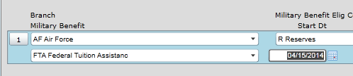

1. Entering End Dates follows same process outlined for GoArmyEd

**SF182 CIVILIAN FUNDING**

1. This coding is applied when an Army Civilian has been approved to use funding to take courses through the GoArmyEd portal

* Usually entered by Laura Coulter

1. Military Branch will always be Army
2. Choose “Civilian” as Military Status and “SF182 Army Civilian Training” is Military Benefit

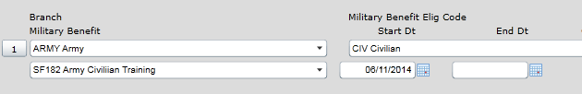

1. For Start Date and End Date, follow same process as outlined for GoArmyEd

**MULTIPLE MILITARY BENEFITS**

1. Do have the ability to enter multiple military benefits, in the event student is using:

* GoArmyEd and National Guard Scholarship
* Other Federal Tuition Assistance and National Guard Scholarship

1. To enter an additional benefit, click in any of the fields within the Military Benefit section
2. When the Excel bar appears, click one of the arrows to the second page

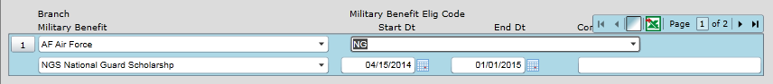

1. A blank data set will appear, allowing you to enter this information

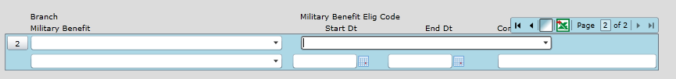

1. Can now go in and enter the additional information
2. Follow documentation outlined above for what to enter in terms of Branch, Status, Start Date, End Date based on additional benefit you are adding

**STUDENT AGREEMENT TRACKING**

1. Functionality still in the process of being developed
2. When completed, will allow for automated creation of Student Agreements and tracking in MILS

